**Assignment 2**

**BTECH (CSBS) Sem VII**

**Subject: Mobile Computing**

1. How is mobility restricted using WLANs? What additional elements are needed for roaming between networks, how and where can WLANs support roaming? In your answer, think of the capabilities of layer 2 where WLANs reside.

Without further mechanisms mobility in WLANs is restricted to the coverage of a single access point. In order to support roaming additional, inter access point protocols are needed. The access points have to inform each other about the current active stations within their coverage. This approach is only feasible for local areas, otherwise location registers etc. similar to GSM are required. The access points simply operate as transparent, self-learning bridges that need additional information to ―forget‖ stations faster compared to the aging mechanisms in fixed network bridges. Station identification is based on MAC addresses. Roaming typically requires a switched layer-2-network.

1. If Bluetooth is a commercial success, what are remaining reasons for the use of infrared transmission for WLANs?

One reason for infrared is still cost – IR devices are very cheap and very simple to integrate. Another advantage is the simple protection from eavesdropping. Attackers can much more easily tap Bluetooth communication, incautious users even let their Bluetooth devices open for public access (simply scan for Bluetooth devices at public devices - many are detectable). IR communication is much more secure as the devices have to face each other (directed IR).

1. How do 802.11 and Bluetooth solve the hidden terminal problem.

802.11 uses the MACA mechanism sending RTS/CTS to solve the hidden terminal problem. In Bluetooth, too, are no hidden terminals as the master controls all visible slaves. If a terminal does not see the master it cannot participate in communication. If this terminal sends anyway, it will not interfere as this terminal, then acts as master with a different hopping sequence.

1. How are fairness problems regarding channel access solved in IEEE 802.11 and Bluetooth respectively?

802.11 implements a back-off mechanism that tries to offer fair access to the medium in the standard case (no polling from the access point). If all systems behave well this mechanism gives a fair share of the overall bandwidth to all stations. In Bluetooth medium access is controlled by an access point or master, respectively. Fairness then depends on these special nodes, which also decide upon the waiting time of a packet when it will be transmitted. In 802.11 the waiting time directly influences the chances for transmission in the next contention cycle.

1. Explain the access methods used in 802.11.

## Method 1

* + station ready to send starts sensing the medium (Carrier Sense based on CCA, Clear Channel Assessment)
  + if the medium is free for the duration of an Inter-Frame Space (IFS), the station can start sending (IFS depends on service type)
  + if the medium is busy, the station has to wait for a free IFS, then the station must additionally wait a random back-off time (collision avoidance, multiple of slot-time)
  + if another station occupies the medium during the back-off time of the station, the back-off timer stops (fairness)

## Method 2

* Sending unicast packets
  + station has to wait for DIFS before sending data
  + receivers acknowledge at once (after waiting for SIFS) if the packet was received correctly (CRC)
  + automatic retransmission of data packets in case of transmission errors

1. Explain carrier sensing and different ways of carrier sensing in 802.11.

* **In IEEE 802.11, carrier sensing is performed** 
  + at the air interface (*physical carrier sensing*), and
  + at the MAC layer (*virtual carrier sensing*)
* **Physical carrier sensing**
  + detects presence of other users by analysing all detected packets
  + Detects activity in the channel via relative signal strength from other sources
* **Virtual carrier sensing** is done by sending MPDU duration information in the header of RTS/CTS and data frames
  + Channel is busy if **either** mechanism indicates it to be
  + Duration field indicates the amount of time (in microseconds) required to complete frame transmission
  + Stations in the BSS use the information in the duration field to adjust their network allocation vector (NAV)

1. Differentiate between layered and clustered architecture of WSN.

#### Layered Network Architecture

This kind of network uses hundreds of sensor nodes as well as a base station. Here the arrangement of network nodes can be done into concentric layers. It comprises five layers as well as 3 cross layers which include the following.

The five layers in the architecture are:

* Application Layer
* Transport Layer
* Network Layer
* Data Link Layer
* Physical Layer

The three cross layers include the following:

* Power Management Plane
* Mobility Management Plane
* Task Management Plane

These three cross layers are mainly used for controlling the network as well as to make the sensors function as one in order to enhance the overall network efficiency. The above mentioned five layers of WSN are discussed below.

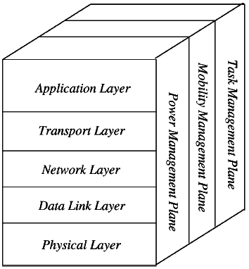

#### Clustered Network Architecture

In this kind of architecture, separately sensor nodes add into groups known as clusters which depend on the “Leach Protocol” because it uses clusters. The term ‘Leach Protocol’ stands for “Low Energy Adaptive Clustering Hierarchy”. The main properties of this protocol mainly include the following.

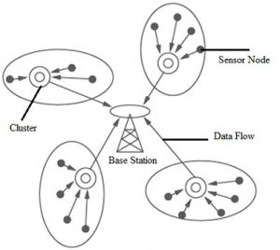

This is a two-tier hierarchy clustering architecture.

* This distributed algorithm is used to arrange the sensor nodes into groups, known as clusters.
* In every cluster which is formed separately, the head nodes of the cluster will create the TDMA (Time-division multiple access) plans.
* It uses the Data Fusion concept so that it will make the network energy efficient.

**Note: Submission Date: 10/10/2022**